**DATA ANALYSIS**

In the following summary, we use the somewhat emotive terms ‘rich’ to mean the top 25% of income earners, and poor to mean the bottom 25%. The unhealthy behavior rate is an average of the rates for all unhealthy behaviors (e.g. smoking, obesity etc), and the same applied to preventative measures rate (e.g. annual health check), and health outcomes rate (e.g. cancer, heart disease).

**Best and Worst, States and Cities Summary**

|  |  |  |
| --- | --- | --- |
| *NB: Order is Best, 2nd Best, 3rd Best* | **Best States** | **Worst States** |
| **Life Expectancy** | Hawaii, Idaho | Nevada, Oklahoma: ~2.8years worse |
| **Rich/Poor Gap in Life Expectancy** | California, New Mexico, Florida | Wyoming, Delaware, Maryland: ~5 years worse |
| **Unhealthy Behaviour Rate** | Vermont, Colorado, Utah: ~21% | Mississippi, New Jersey, Delaware: ~30% |
| **Serious Disease Rate** | Vermont, North Dakota, Minnesota: ~10% | West Virginia, Ohio, Mississippi: ~16% |
| **Heart Disease Rate** | Vermont, DC, Alaska, Utah: ~4% | West Virginia, Ohio, Pennsylvania: ~8% |
| **Smoking Rate** | Utah, California, Hawaii: ~13% | Ohio, Maryland, Mississippi: ~25% |
| **Obesity Rate** | Vermont, Hawaii, Colorado: ~20% | Mississippi, Delaware, Louisiana: ~37% |
| **Dental Health (>65yo, lost all teeth)** | Hawaii, Minnesota, North Dakota: ~7% | Ohio, West Virginia, Mississippi: ~23% |
|  |  |  |
|  | **Best Cities** | **Worst Cities** |
| **Life Expectancy** | Santa Fe NM, San Jose/Sunnyvale/Santa Clara CA | Columbus GA, Henderson NV, Las Vegas NV: ~4 years worse |
| **Rich/Poor Gap in Life Expectancy** | Laredo TX, Yuma AZ | Wichita Falls TX, Champaign IL, Decatour IL:~8 years worse |
| **Unhealthy Behaviour Rate** | Newport Beach/Irvine CA, Boulder CO: ~17% | Detroit MI, Camden NJ, Youngtown OH, Flint MI, Gary IN: ~35% |
| **Serious Disease Rate** | College Station TX, Irvine/Mountain View CA: ~8% | Gary IN, Youngstown OH, Detroit/Flint MI: ~20% |
| **Heart Disease Rate** | College Station TX, Provo UT: ~2.6% | Youngstown OH, Gary IN: ~10% |
| **Smoking Rate** | Orem UT, Sunnyvale/Newport Beach CA: ~9% | Flint MI, Detroit MI, Youngstown OH: ~30% |
| **Obesity Rate** | Irvine/Fremont/Milpitas CA, Boulder CO: ~15% | Gary IN, Detroit MI, Reading PA, Birmingham AL: ~44% |
| **Dental Health (>65yo, lost all teeth)** | San Remon/Redondo Beach CA: ~5% | Gary IN, Trenton NJ, Youngstown OH: ~30% |

While, for brevity, the above table only shows the top 2 or 3 best/worst cities or states, it is notable that the same cities/states keep appearing in different categories. For example Gary, Indiana is the worst city for Dental health, obesity, smoking and therefore among the worst cities for overall unhealthy behaviors. It is therefore unlikely to be a coincidence that it also has the worst overall rate of Serious Disease, and the 5th lowest life expectancy. For States, Vermont has the lowest obesity rates (and overall Unhealthy Behavior Rate), and again probably not coincidentally, the lowest serious disease rate.

Since states or cities that are the worst with one unhealthy behavior tend to be the worst with other unhealthy behaviors (and the same applies to serious diseases and preventative measures) there are clearly underlying probable socio-economic factor(s) driving this. Whilst there is clearly insufficient data to establish the causal factors, we can hypothesize that income-related factors such as education and health-insurance may be contributing factors.

**Life Expectancy and Health**

The chart below shows a high level of stratification of life expectancy by income quartile, showing an approximate 8 year gap between the rich and the poor. We can also see that the relationship between the general health of a city and life expectancy though it appears to be only as little as a year for cities with the worst health to those with the best. So rather surprisingly the impact of wealth on life expectancy seems much more significant that the general health of the city.

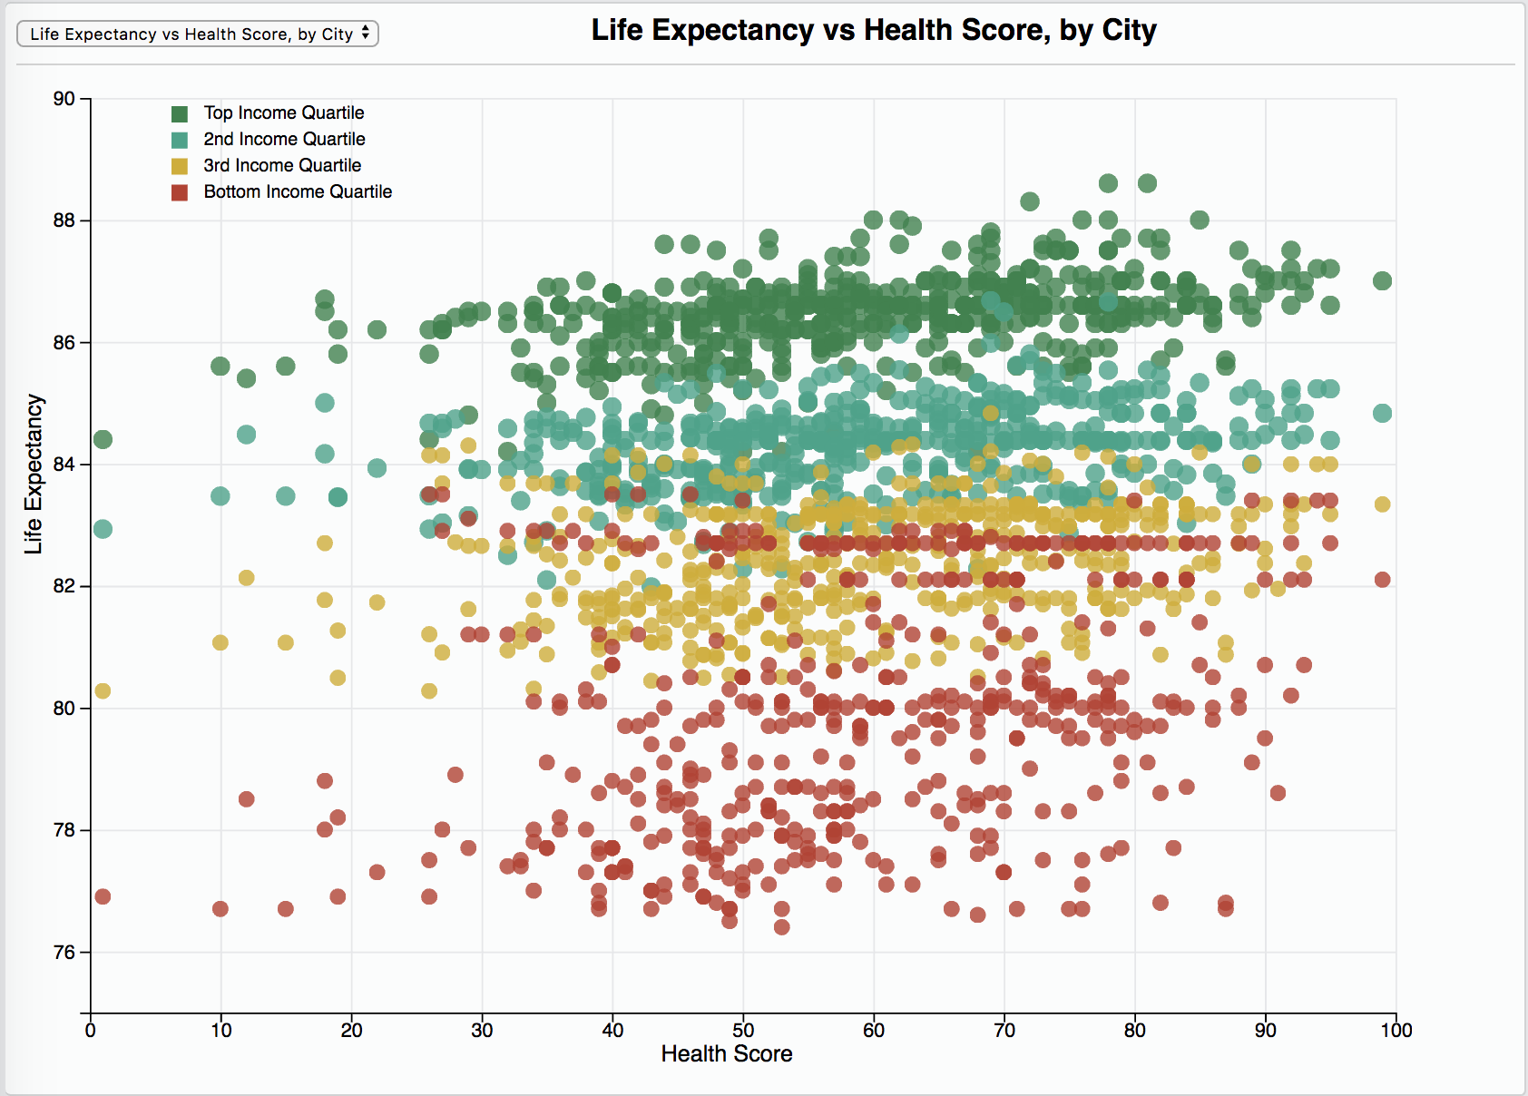

The following three charts regression slopes show that life expectancy for the poor is much more adversely associated with Unhealthy Behaviours, and Health Outcomes (Problems), than for the rich. And also that the poor have much more benefit from preventative measures.

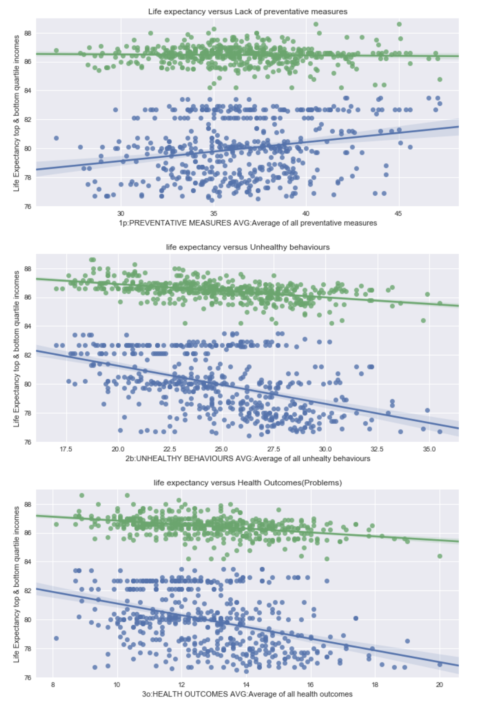

The following charts show that both rich and poor life expectancy is affected by Smoking, Obesity and Inactivity, but again the regression slopes show that the poor are much more affected than the rich. Somewhat surprisingly Binge Drinking seems to have almost no relationship to life expectancy, and for the rich there is actually a slight positive relationship. We can only hypothesize that other factors such as age, or wealthy enough to afford to binge drink is balancing the negative effects.

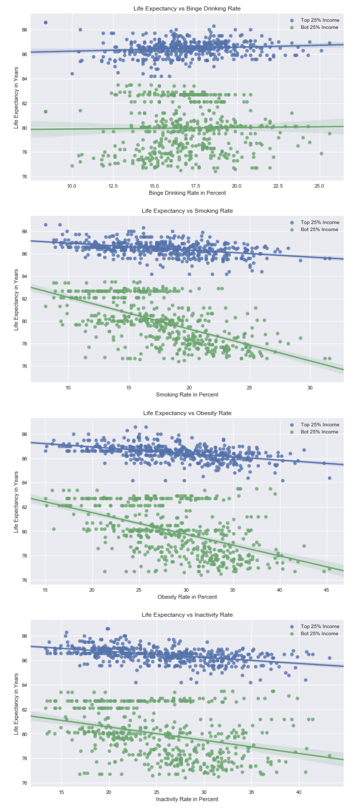

**Other Notable Findings**

Large cities (over 1 million) have slightly worse preventative measures, and slightly worse unhealthy behaviors than smaller cities, however the average life expectancy is essentially identical. They also have slightly lower life expectancy gaps between rich and poor.

There is a region of central Illinois where the rich vs poor life expectancy gap is wide (Champaign Illinois has the second-most unequal life expectancy between rich and poor. There is also region of far southern Texas where this gap is quite small.

There is a fairly high correlation (0.75) between average life expectancy and the gap in life expectancy between rich and poor. So unfortunately it seems there is little trickle-down effect from good health in the rich to good health in the poor. This is confirmed by surprisingly low correlations of only 0.33 and 0.5, for women and men respectively, between the life expectancy for the rich and life expectancy for the poor.

In addition to the above, the correlation coefficient of Preventative Measures and Health Outcomes is only 0.27, so while there may be other hidden factors, this low rate does imply that Annual Checkups, Cholesterol screening etc. (full list in the Appendix), are having a limited impact on health outcomes (disease). Whereas the correlation coefficient of Unhealthy Behaviors and Health Outcomes is 0.84 indicating a very strong relationship between measures such as smoking obesity etc. and cancer, heart disease etc. A reasonable (but not provable) hypothesis from this data is that this relationship is causative. So while Preventative Measures appear not to be particularly ‘preventative’, it appears that Unhealthy Behaviors may be strongly causative.

So while the income vs life expectancy data showing a very significant impact of wealth (or lack thereof) on life expectancy, is bad news for those near the bottom of the socio-economic ladder. The good news is that this can to some extent be mitigated by an individual’s choice to reduce their Unhealthy Behaviors.